**1. The height of a tree is defined as the number of edges on the longest path in the tree. The function shown in the pseudocode below is invoked as height (root) to compute the height of a binary tree rooted at the tree pointer root.**

[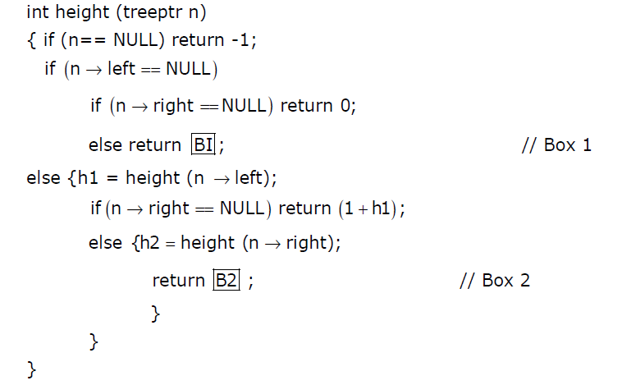](http://d1gjlxt8vb0knt.cloudfront.net/wp-content/uploads/gat2012height.png)  
**The appropriate expression for the two boxes B1 and B2 are**  
(A) B1: (1 + height(n->right)), B2 : (1 + max(h1,h2))  
(B) B1 : (height(n->right)), B2 : (1 + max(h1,h2))  
(C) B1 : height(n->right), B2 : max(h1,h2)  
(D) B1 : (1 + height(n->right)), B2 : max(h1,h2)

**2. It is desired to design an object-oriented employee record system for a company. Each employee has a name, unique id and salary. Employees belong to different categories and their salary is determined by their category. The functions to get Name, getld and compute salary are required. Given the class hierarchy below, possible locations for these functions are:**

i. getld is implemented in the superclass  
ii. getld is implemented in the subclass  
iii. getName is an abstract function in the superclass  
iv. getName is implemented in the superclass  
v. getName is implemented in the subclass  
vi. getSalary is an abstract function in the superclass  
vii. getSalary is implemented in the superclass  
viii. getSalary is implemented in the subclass

[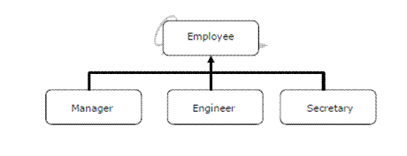](http://geeksforgeeks.org/wp-content/uploads/gate_2004.gif)

Choose the best design

(a) (i), (iv), (vi), (viii)  
(b) (i), (iv), (vii)  
(c) (i), (iii), (v), (vi), (viii)  
(d) (ii), (v), (viii)

**3. Which one of the following are essential features of an object-oriented programming language?**

(i) Abstraction and encapsulation  
(ii) Strictly-typedness  
(iii) Type-safe property coupled with sub-type rule  
(iv) Polymorphism in the presence of inheritance

**Options:**

(a) (i) and (ii) only  
(b) (i) and (iv) only  
(c) (i), (ii) and (iv) only  
(d) (i), (iii) and (iv) only

**4. An undirected graph G(V, E) contains n ( n > 2 ) nodes named v1 , v2 ,….vn. Two nodes vi , vj are connected if and only if 0 < |i – j| <= 2. Each edge (vi, vj ) is assigned a weight i + j. A sample graph with n = 4 is shown below.**

[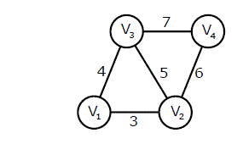](http://geeksforgeeks.org/wp-content/uploads/gate_2011_4.gif)

**What will be the cost of the minimum spanning tree (MST) of such a graph with n nodes?**(A) 1/12(11n^2 – 5n)  
(B) n^2 – n + 1  
(C) 6n – 11  
(D) 2n + 1

**5.The length of the path from v5 to v6 in the MST of previous question with n = 10 is**  
(A) 11  
(B) 25  
(C) 31  
(D) 41

**6.Consider two binary operators ‘↑ ‘ and ‘↓’ with the precedence of operator ↓ being lower than that of the ↑ operator. Operator ↑ is right associative while operator ↓ is left associative. Which one of the following represents the parse tree for expression (7 ↓ 3 ­↑ 4 ­↑ 3 ↓ 2)?**

[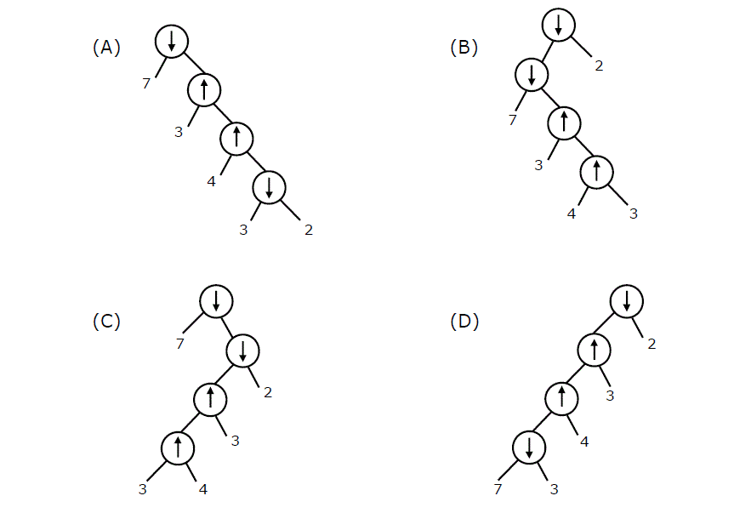](http://geeksforgeeks.org/wp-content/uploads/gate_2011_5.gif)

**7. The elements 32, 15, 20, 30, 12, 25, 16 are inserted one by one in the given order into a Max Heap. The resultant Max Heap is.**

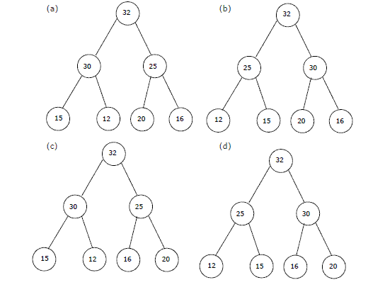

**8. Consider the following C-program:**

|  |
| --- |
| void foo(int n, int sum)  {    int k = 0, j = 0;    if (n == 0) return;      k = n % 10;    j = n / 10;    sum = sum + k;    foo (j, sum);    printf ("%d,", k);  }    int main ()  {    int a = 2048, sum = 0;    foo (a, sum);    printf ("%d\n", sum);      getchar();  } |

**What does the above program print?**  
(a) 8, 4, 0, 2, 14  
(b) 8, 4, 0, 2, 0  
(C) 2, 0, 4, 8, 14  
(d) 2, 0, 4, 8, 0

**9. The time complexity of the following C function is (assume n > 0 )**

|  |
| --- |
| int recursive (mt n)  {     if (n == 1)       return (1);     else       return (recursive (n-1) + recursive (n-1));  } |

a) 0(n)  
b) 0(nlogn)  
c) 0(n^2)  
d) 0(2^n)

**10. When inorder traversing a tree resulted E A C K F H D B G; the preorder traversal would return**

a. FAEKCDBHG  
b. FAEKCDHGB  
c. EAFKHDCBG  
d. FEAKDCHBG

|  |  |  |  |
| --- | --- | --- | --- |
|  | |  |  | | --- | --- | |  |  |   11.What are the two ways to determine the structure of a table in database?  Options  A- Using DESCRIBE command and dbms_metadata_get_commit package  B- Using METADATA command STRUCTURE commands  C- Using DATA_ON_DATA and STRUCTURE commands  D- Using DESCRIBE command and dbms_metadata.get_ddl statement  12.Which of the following queries are legal?  Options  A- SELECT deptno, count(deptno) FROM emp GROUP BY ename;  B- SELECT deptno, count(deptno), job FROM emp GROUP BY deptno;  C- SELECT deptno, avg(sal) FROM emp;  D- SELECT deptno, avg(sal) FROM emp GROUP BY deptno;  13. Which of the following SQL operations demands the use of wild cards comparisons?  Options  A- IN  B- BETWEEN  C- EXISTS  D- LIKE  14. What operator is used to prevent the error: ‘ORA-01427:single row sub query returns more than one row’ ?  Options  A- Use the IN operator  B- Use the >= operator  C- Use the CAN EXIST operator  D- Use the = operator  15. Which of the following queries displays the sum of all employee salaries for those employees not making commission, for each job, including only those sums greater than 2500?  Options  A- select job, sum(sal) from emp where sum(sal) > 2500 and comm is null;  B- select job, sum(sal) from emp where comm is null group by job having sum(sal) > 2500;  C- select job, sum(sal) from emp where sum(sal) > 2500 and comm is null group by job;  D- select job, sum(sal) from emp group by job having sum(sal) > 2500 and comm is not null;  16. Multiple inheritance means,  (a) one class inheriting from more super classes  (b) more classes inheriting from one super class  (c) more classes inheriting from more super classes  (d) None of the above  (e) (a) and (b) above. |
|  |  |
|  |
|  |  |
|  |

**17) Station A needs to send a message consisting of 9 packets to Station B using a sliding window (window size 3) and go-back-n error control strategy. All packets are ready and immediately available for transmission. If every 5th packet that A transmits gets lost (but no acks from B ever get lost), then what is the number of packets that A will transmit for sending the message to B?**  
(A) 12  
(B) 14  
(C) 16  
(D) 18

**18) Match the following:**

**(P) SMTP (1) Application layer**

**(Q) BGP (2) Transport layer**

**(R) TCP (3) Data link layer**

**(S) PPP (4) Network layer**

**(5) Physical layer**

(A) P – 2 Q – 1 R – 3 S – 5  
(B) P – 1 Q – 4 R – 2 S – 3  
(C) P – 1 Q – 4 R – 2 S – 5  
(D) P – 2 Q – 4 R – 1 S – 3

**19) Write down a program to get the factorial of a given number using recursion (using language of your choice), program should not allow inputs for which factorial is not possible e.g. decimal, strings etc. and edge cases must be handled using error handling.**

**a. Write down the time complexity for the same.**

**b. Write down the case for which your program may give an error at runtime (if any).**

**Factorial: The**factorial of a**positive**number**n is**given**by:**factorial**of n (n!) = 1*2*3*4....n. The**factorial of a **negative**number**doesn't exist. And, the**factorial**of 0 is 1**

**20) Write down a program to reverse a string (using language of your choice), also write down the time complexity for the same.**